Ideation Phase
Define the Problem Statements
DATE | 24-09-2026
TEAM ID | SWTID-2026-2737
PROJECT NAME | AI WeatherWise API
MAXIMUM MARKS | 2 Marks
Customer Problem Statement Template:
The Ideation Phase is the first step in the design thinking process. It helps us understand the problem, think creatively and generate useful ideas. In this phase, we first define the problem statement from the customer's point of view. Then we brainstorm, group similar ideas and finally prioritize the best ideas for our project.
The Customer Problem Statement template helps us understand the customer's perspective and focus on what really matters. It allows us to create solutions that people will love. A well-articulated problem statement helps our team empathize with the users and find the right solution for their challenge
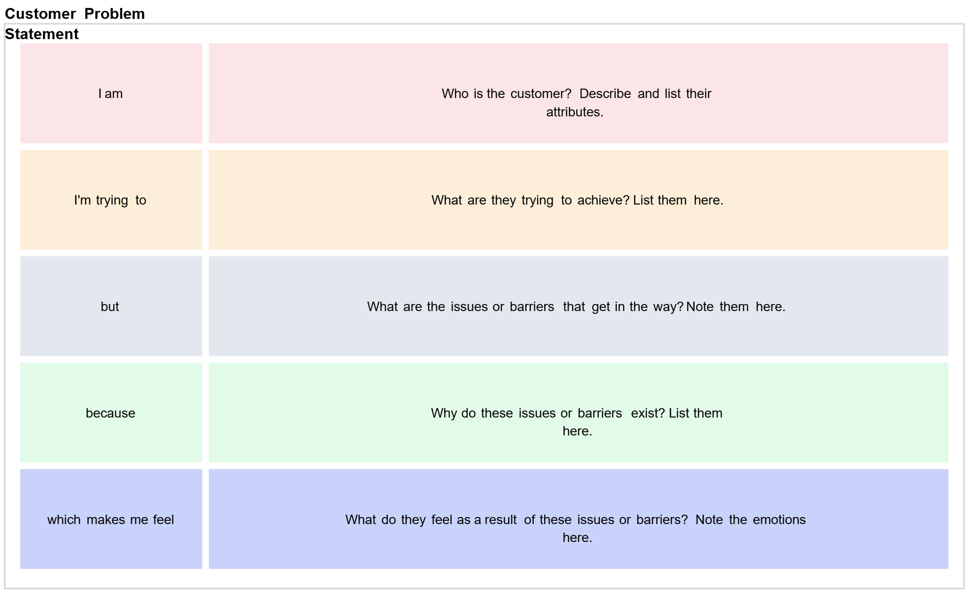
EXAMPLE:
